COMP23420 Software Engineering
Semester 2, 2013/2014, Team Project Weeks 1 – 4
Report 1

Due: Week 4 Lab
Team ID: T4
Team member and signature:
Absent members and reasons, if known:
Member: Kashif Hussain
07/02/2014 Reason Given: Illness
Member: Jonathan Bailey
31/01/2014 Reason Given:
07/02/2014 Reason Given:

Work Plan and Actual Performance (One Page Maximum)

Task (What) | Assigned to Team Member (Who) | Completed? (When) | Not Completed? (Why)
Your System's actors (both humans and systems), functional requirements and non-functional requirements. | Stefan Andrei Balas | 6/02/2014 | ?
The names of potential use cases for your system | Pruteanu Silviu Adi | 6/02/2014 | ?
The scope and functions of your system | Kashif Hussain | 6/02/2014 | ?
The functions outside your system | Jonathan Bailey | 6/02/2014 | ?
Become familiar with Gitlab | All | ? | ?
Become familiar with wrapper classes and database functions | Stefan Andrei Balas, Pruteanu Silviu Adi | ? | ?
Sketch GUI |  | ? | ?
Create Domain Model |  | ? | ?
Create a Sequence Diagram for “Driver requests holiday” use case |  | ? | ?
Create Detailed Use Case |  | ? | ?
Fill in Glossary |  | ? | ?
Create Design Model |  | ? | ?
Create Test Cases |  | ? | ?
Design GUI | Stefan Andrei Balas, Pruteanu Silviu Adi | ? | ?
Implement GUI | Stefan Andrei Balas, Pruteanu Silviu Adi | ? | ?
Fill in report |  | ? | ?
Reflection on the Plan

Briefly describe (One page maximum):
- What has gone well and what has not.
- What lessons can be learned & how your team can improve in the next iteration.

What has gone well:
- Completed Iteration/all tasks
- Neat/tidy code
- Everyone is familiar with the code/system

What has not:
- Absent members from labs/meetings
- No strict schedule/rushed at the end
- Organizational confusion: Who is doing what?

Lessons to be learned:
- Keep to a strict schedule to maintain good work progress
- Check methods of communication more often to update members on work progress

Other areas of improvement:
- Everything?

Use Cases for IBMS (One Page Maximum)
- A Brief Description of The Use Cases Identified (including the authors’ names)

Use Case Name | Brief Description
UC1: Request holiday | A driver requests a holiday through the system. The system checks for potential conflicts with rostering rules. If there are no conflicts, the system approves the dates, and awaits confirmation.
UC2: Produce / Edit Roster | Produce a roster (duties and driver assignments) based on the timetable provided.
UC3: Manage bus failure | The human controller requests a replacement bus and a driver through the system. The system checks for available buses and drivers, and assigns them.
UC4: Replace driver | The human controller locates a replacement driver through the system. The system checks for available drivers. If there is an available driver, the driver is notified/requested.
UC5: View Timetables | A timetable is generated by the system, which is made available externally for passengers.
UC6: Manage service cancellation  (Cancel a Service) | The human controller attempts to cancel a service through the system. The system relieves all driver's duties for that service.
(continue to add more rows if needed)

2. A detailed description of UC1 (Driver Requesting Holidays) & the related sequence diagram is given below (including the authors’ names):
Use case name | Driver Requesting Holidays
Identifier | UC1
Description | A driver requests a holiday through the system. The system checks for potential conflicts with rostering rules. If there are no conflicts, the system approves the dates, and awaits confirmation.
Participating  Actors | Driver;
Trigger event | Driver requests the holiday through the system
Normal Flow | - Driver enters their number into the designated field.  - Driver number is valid/recognised (checked if it is present in the database)  - Driver specifies the start/end dates of the requested holiday.  - The number of holidays required to fulfill the request is compared with the number of holidays left.  - Check if the requested dates are available (the maximum number of holiday requests for a day has not been exceeded)  - Confirmation is displayed to the driver  - Driver approves his holiday request  - Driver is marked as unavailable on the confirmed dates  - Number of holidays taken is updated
Alternative/exceptional flows | 2.1 If the number is the wrong format/invalid, a message is displayed and the number is requested again  3.1 If not both dates have been selected or  if the end date is before the start date or  if the start date is not at least 7 days from the day the request  was made  a message is displayed and the dates are requested again  4.1.1 If the driver does not have enough holidays left to fulfill the request a message is displayed.  4.1.2 Go back to step 3  5.1.1 If unavailable dates are found, all the unavailable dates are displayed  5.1.2 Approval is blocked and the user can restart the entire process  7.1.1 If the driver declines his request, he is returned to the start screen  7.1.2 No changes are made to the database
Entry condition | Driver enters the request holiday window
Exit conditions | Driver finishes the process  Driver cancels the process

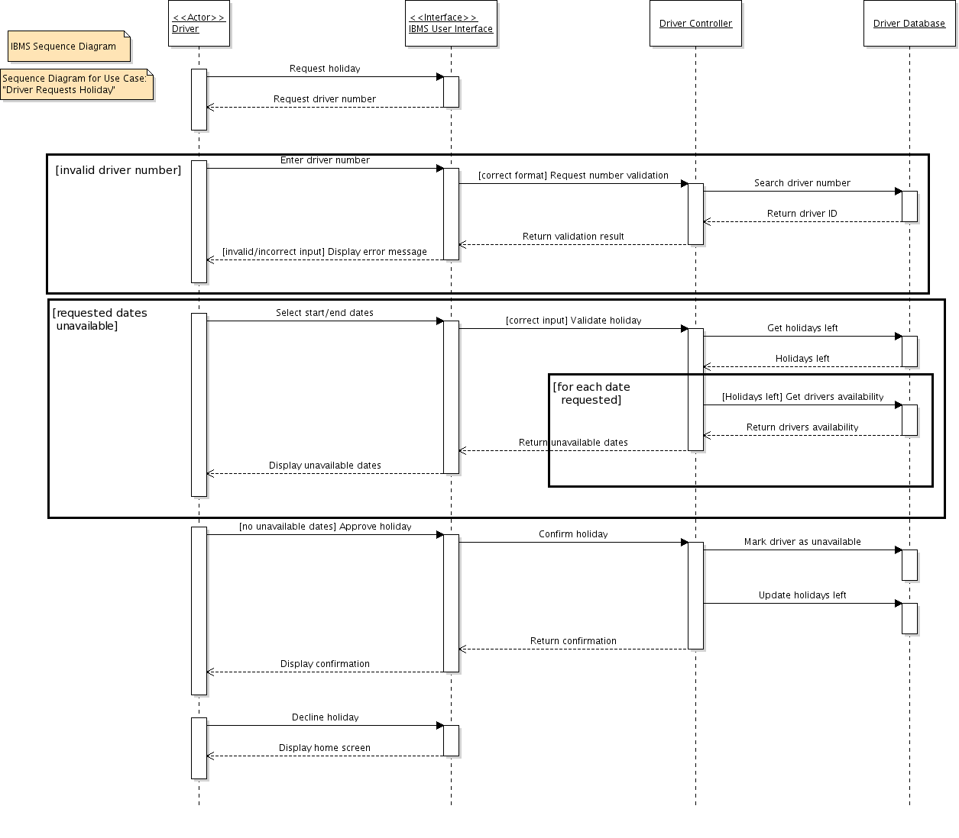
Sequence Diagram for UC1 (Driver Requesting Holidays)
An Initial Glossary for IBMS (One Page Maximum)
The maximum number of business terms you may be able to identify at this stage is 20.
Business Term | One-Sentence Definition
Bus | A bus is a form of public transport that carries passengers in the rural areas.
Driver or Bus driver | The person who drives a bus
Passengers | The people who use the bus as a means of transport in the rural areas
IBMS | An acronym for “Integrated Bus Management System” which will replace the existing legacy system for GMPTE.
Holiday | A period where a driver takes a break from their job for up to 25 days a year.
Human Controller | A person who produces a roster and deals with service cancellations, finding replacement drivers and supplying a replacement bus if a bus breaks down.
Service Cancellation | The act of canceling a service
Roster | A list or plan showing turns of duty or leave for bus drivers
Rostering | The act of producing a roster in accordance with the rostering rules
Rostering Rules | A set of constraints to be taken into account when producing the roster.
Timetable | A chart/schedule showing the departure and arrival times of the buses.
Bus Service | Public transport provided by a company that follows a particular route and timetable.
Driver Shift | A driver shift consists of one period of up to 5 hours driving time, or two such periods with a 1 hour break between them.
Driving Time | Time spent with the bus itself regardless if the bus is moving or not.
Resting Days | The two days each week which the driver will not be able to work on.
Replacement Driver | A driver that replaces another driver who is ill, on holiday or absent for any other reason.
Replacement Bus | A bus that replaces a broken down bus and is available at any time.
Database | Contains bus, driver and timetable information.
Bus Routes | The course a bus takes from its starting location to its destination with designated stops and stations.
Pilot Project | An initial system roll-out planned as a test or trial

Domain Model for IBMS
(Including the authors’ names)

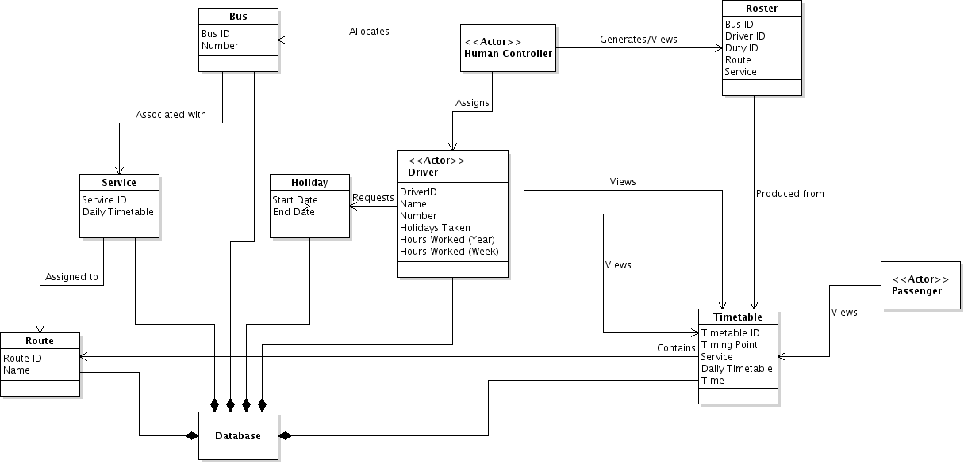
Design Model for IBMS
(Including the authors’ names)
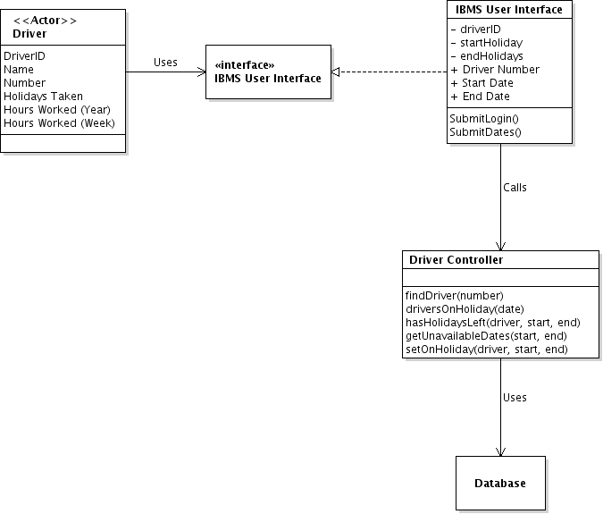
UI Design Sketch
(Including the authors’ names)
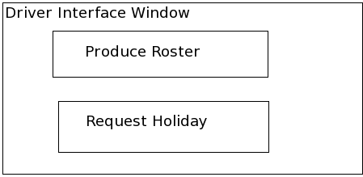
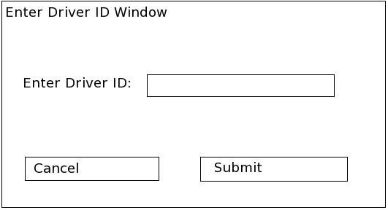
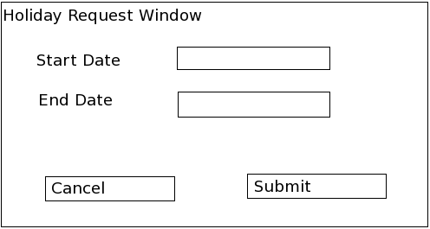
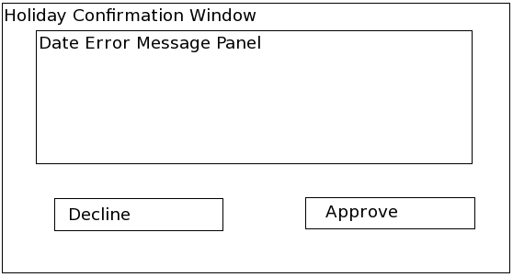
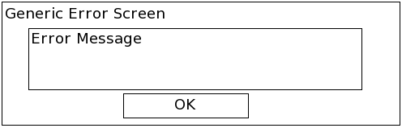
After clicking submit on “Holiday Request Window”:

If an error occurs:
Test Cases
(Including the authors’ names)
Clicking Submit/Approve is implied?
Enter Driver ID Window
Test Case #1: Leave “Enter Driver ID” field blank
Outcome: Error message displayed asking driver to enter their ID into the field

Test Case #2: Enter characters other than numbers
Outcome: Error message displayed asking driver to only enter the numbers which form their ID

Test Case #3: Enter a driver ID which does not exist in the database
Outcome: Error message displayed saying that ID does not exist and asking driver to re- enter their ID?

Holiday Request Window
Test Case #4: Leave either or both start date and end date fields blank
Outcome: Error message displayed asking driver to enter a date in respective blank fields

Test Case #5: Enter an end date or start date which is before or after the specified start date or end date respectively
Outcome: Error message displayed asking driver to enter either:
      - A start date which is before the end date
      - An end date which is after the start date

Test Case #6: Enter a start date which is less than 7 days after the current day
Outcome: Error message displayed asking driver to enter a start date which is, at least, 7 days from now.

Test Case #7: Enter a start date and end date which encompass more days than holidays left for the year
Outcome: Holiday confirmation window displayed asking driver to enter a start date and end date so that it is less than or equal to their remaining holidays for the year

Test Case #8: Enter a start date and end date which encompasses a date where the maximum amount of drivers (10) have booked a holiday on that date
Outcome: Holiday confirmation window displayed showing the dates which are fully booked and asking driver to enter a start date and end date so that it does not encompass a date which has been fully booked for holidays

